**Among us Hack** 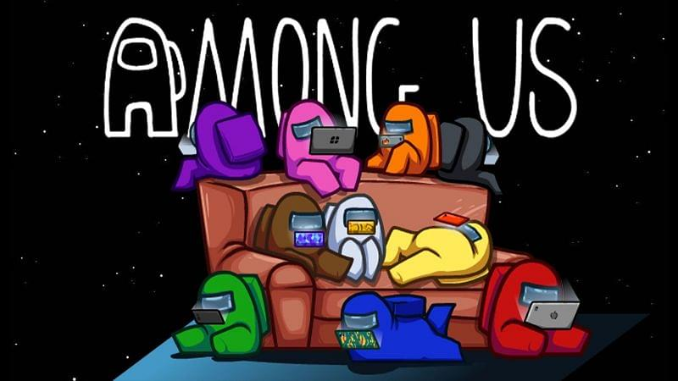

**Among us**, an online multiplayer game developed in 2018 by American game studio Innersloth is one of the most famous game at this time with million of players playing it on a regular basis. So, the development of **cheat hacks** can’t be ignored because of its popularity.

**This’s just an informative article on what are the existing *hacks* in *Among us*, how do they function, etc. But we don’t support or condone hacking and cheats anyhow, if you’ll do so then you’ll get your account banned indelibly, if caught. It’s 100% unethical to use them.**

Some of the unknown attributes in the *Among Us hacks* incorporate Wallhack, ESP, Instant Kill, and others. By utilizing these *Among us cheats and hacks*, one can smoothly switch through the GUI menu using their setting and thus can fortuitously apply them while enjoying the game. Here’s the list of the *cheats* and *hacks* present in Among us:

Ghost Chat shown

Wall Ignorance

Speed Hack

Item Hack

Radar Hack

Map Hack

Door Cooldown

Killing other players instantly

Chat delay removal

Disabling killing

Limitless Vandalization

Be an Imposter

Imposters Detection

All player’s ESP (Extra Sensory Perception)

Eternal hack 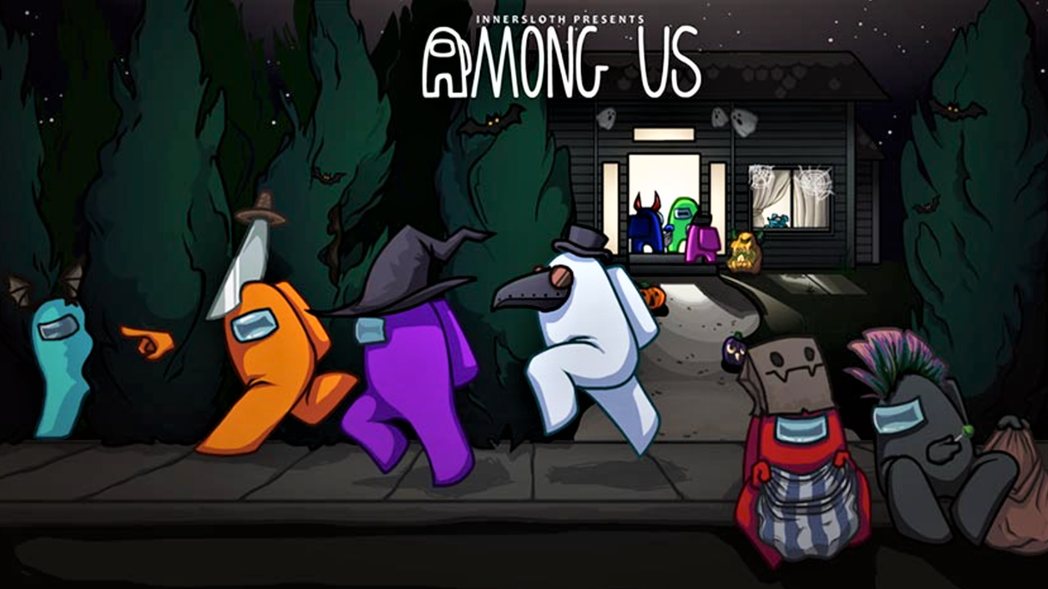

If you’re playing by using these *hacks* then you shouldn’t be sceptical about the other players information provided to you by these and you should utilise them completely. If you’re using these *hacks* then it’ll let you know the location, belongings and the part of other players in the game. And when you’re able to find the imposter then you can use instant kill hack to determine its correctness, no need to hold back your views for the discussion table.

Moreover, you’ll have immortal *hack* which will not let you die. You can use item and speed *hack* to get to any point of the map without the need to know them properly. By using item *hack*, you can unlock items like hats, pets, skins, and others. So, you’re provided every *hack* one needs to win. So, enjoy the game by playing either as an imposter or normal player, result will be your side only.

**Among us hacks** and **cheats** download:

Skycheats is the most reliable source for downloading *Among us hacks*. Other websites may contain Backdoor programs or Trojan which will destroy your computer in no time. So, use skycheats only. It’s reliable cause it has a proper customer service management team who’ll help people if they’re facing problem while cheating. So, you can download and enjoy them.